Executive Summary of the Siouxland Social Service Utilization Study
Overview:
In early 2013, Briar Cliff University’s Siouxland Research Center (SRC) was contacted by the Comprehensive Strategy Council about conducting a study of Woodbury County residents whose income levels fell at or below the poverty level. The primary purpose of the study was to help determine what barriers, if any, prevented residents from utilizing social service agencies in the Siouxland area. To help answer this question, the SRC first conducted focus groups with members of the target population, and then mailed surveys to approximately 1500 Woodbury Country residents who met study criteria.
Methodology:
With the help of several Siouxland area clergy, the SRC staff contacted individuals who had utilized social service agencies within the Siouxland area. The purpose of the first focus group was twofold: to identify local social service agencies and to get as thorough an understanding as possible of issues related to the utilization, or lack thereof, of local agencies. The first focus group had eight attendees, all of whom had some history of using social service agencies. Regarding demographics, five of the attendees were female, five were Caucasian, two were African-American, and one was Hispanic.
At the beginning of the first focus group, attendees were each asked to name all of the agencies in the Siouxland area with which they were familiar. Next, they were asked questions related to their general experiences with agencies such as “What have your experiences been with obtaining services in Woodbury County?” “Have there been social services you have needed but not applied for – why or why not?” “Are there agencies in town that have a bad reputation that people end up avoiding?” and “Are there agencies in town that have a good reputation that people seek out?” In total, focus group attendees were asked eight questions. The focus group met for approximately 1.5 hours, and all attendees were given $20 Hy-Vee gift cards for their participation.
The second focus group met approximately two weeks later. All original focus group members attended the second meeting in addition to four new members. With respect to demographics, eight of the attendees were female, seven were Caucasian, three were African-American, and two were Hispanic. The purpose of the second focus group was to have the attendees look over the survey, and to make suggestions about ways to improve it. Again, this group met for approximately 1.5 hours, and all attendees were given $20 Hy-Vee gift cards for their participation.
After changes were made to the questionnaires based on feedback from the second focus group, surveys were mailed to 1,500 Woodbury country residents whose income was less than $15,000. Approximately 230 envelopes were returned, although 23 were excluded from the analysis due to study ineligibility (i.e., did not list income, earned too much). An additional 208 surveys were collected from Siouxland members in the community.
Findings
Demographic Information:
The majority of respondents were female, Caucasian, between the ages of 26 and 35, had children under the age of 18, and had never been married. With respect to employment and finances, a slight majority of respondents were employed, less than half received health insurance through their employment, and almost 75% earned less than $10,000 annually (see Table 1 for complete list of demographics).

Table 1: Respondent demographics
Total
N = 415
Gender, % females | 67.2% | Marital Status  Married  Widowed  Separated  Divorced  Single | 24.3%  15.4%  6.0%  16.4%  37.8%
Age, yrs  18-25  26-35  36-45  46-55  56+ | 09.9%  28.2%  16.9%  16.1%  25.5% | Cur. Employed; % Yes | 52.3%
Ethnicity  African-American  Caucasian  Hispanic  Other | 08.4%  74.0%  11.1%  06.5% | Health insurance., % yes | 31.1%
English 1st language, %yes | 92.8% | Annual income  Less than $5,000  $5,001-$10,000  $10,001-$15,000 | 22.4%  51.1%  26.5%
Children <18  0  1  2  3  4+ | 29.4%  42.9%  16.4%  9.9%  1.4% | Sources of support  SS/SD  Food stamps  Other social welfare  Alimony/CS  Rent suppl.  Family/friends | 33.7%  52.0%  15.7%  08.2%  27.2%  22.7%
Primary support children; % yes | 65.1%
Access to car; % yes | 79.3%

Knowledge of services:
After questions related to demographic information, respondents were asked if they knew where to go to receive services in a variety of domains (e.g., medical, legal, housing, etc…). The majority of respondents answered affirmatively to almost all questions related to knowledge of where to obtain services. For example, approximately 88% knew where to obtain medical services and 66% knew where to obtain food for themselves or their family. Of note, less than half knew where to obtain emergency shelter (45.5%) or help with child care (37.8%).

Chi-square analyses were conducted to determine if knowledge of services differed significantly by gender. Males were significantly less likely to know where to obtain all services that were asked about. For example, approximately 91% of women knew where to obtain mental health services compared to only 54% of males and 78% of women knew where to obtain substance abuse services compared to 26% of males (please see Figures 1 and 2; see Appendix 1 for all charts related to knowledge questions).
Figures 1 and 2: Medical and substance abuse by gender
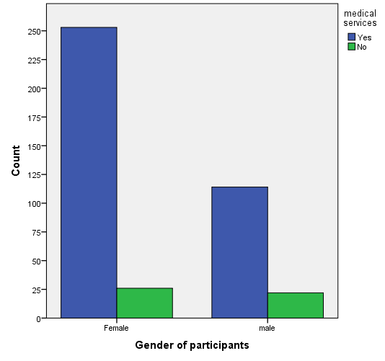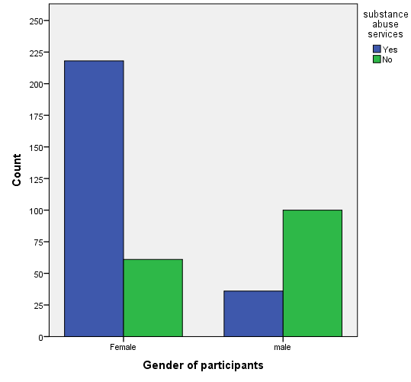

Chi-square analyses were also conducted to determine if knowledge of services differed significantly by ethnicity. When compared to other ethnic groups, African-American respondents were significantly less likely to know where to receive many of the services listed in the survey. For example, over 90% of Caucasian and Hispanic respondents knew where to receive medical care whereas only 66% of African American respondents did. None of the African-American respondents knew where to receive legal help, compared to approximately 56% of Caucasian and Hispanic respondents.
Figures 3 and 4: Medical and Legal assistance by ethnicity
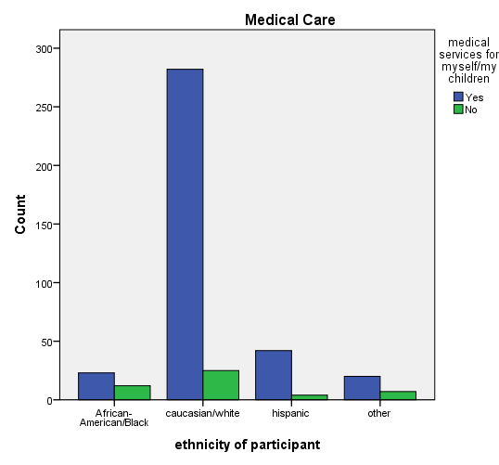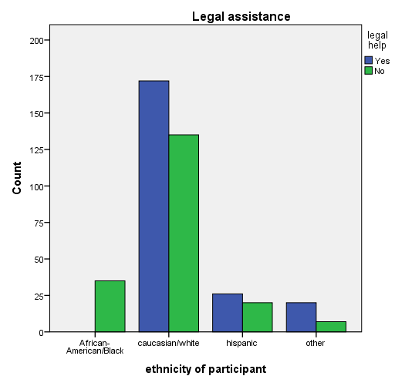
Agency Satisfaction:
The remaining questions on the survey asked respondents about their satisfaction with social service agencies in a variety of domains. As noted in Table 2, the majority of respondents agreed or strongly agreed with questions related to service accessibility, consumer-staff relations, and understanding of agency rules.

Table 2: Agency Satisfaction
Item | Strongly Agree 1 | Agree  2 | Neutral  3 | Disagree  4 | Strongly Disagree  5 | Mean
Agencies are child friendly | 10.4% | 32.3% | 27.2% | 9.6% | 1.7% | 2.27
Agency staff clearly explain the services available | 16.4% | 42.4% | 31.1% | 5.1% | 00.0% | 2.26
Agency staff clearly explain the reasoning for required paperwork | 13.0% | 45.8% | 26.3% | 8.2% | 1.7% | 2.37
Agency staff clearly explain the rules to obtain services | 15.2% | 41.2% | 27.7% | 9.2% | 1.7% | 2.38
Agency staff clearly explain the order in which people receive services | 15.9% | 36.9% | 28.4% | 13.5% | 00.0% | 2.42
Agency staff gave me information about my rights | 16.9% | 45.5% | 25.3% | 7.2% | 00.0% | 2.24
The waiting time to receive services from when I requested them is reasonable | 15.9% | 37.8% | 28.2% | 9.6% | 3.4% | 2.44
Agency staff treated me with respect | 21.0% | 32.5% | 17.1% | 21.0% | 3.4% | 2.51
Agency staff were respectful of my cultural background | 21.2% | 35.7% | 23.4% | 13.3% | 1.4% | 2.35
Item | Strongly  Agree  1 | Agree  2 | Neutral  3 | Disagree  4 | Strongly Disagree  5 | Mean
Agency staff were friendly | 17.6% | 35.7% | 16.6% | 20.2% | 4.8% | 2.57
Agency staff see me as someone worth helping | 14.5% | 29.6% | 32.0% | 15.4% | 3.4% | 2.62
I feel pressured by staff to do what agency staff want | 9.6% | 22.7% | 39.5% | 15.9% | 7.2% | 2.88
The location of services are convenient | 12.8% | 49.6% | 26.0% | 3.4% | 3.1% | 2.31
Services are available at good times for me | 13.3% | 47.5% | 29.2% | 3.4% | 1.7% | 2.29
I receive as much help as I need | 9.9% | 31.3% | 22.7% | 24.6% | 6.5% | 2.86
I would use services again if needed | 22.7% | 44.8% | 25.8% | 00.0% | 1.7% | 2.09
I would recommend using agencies to other people | 22.7% | 41.2% | 24.8% | 6.3% | 00.0% | 2.15

As previously noted, respondents’ reports of agency satisfaction were generally positive. In order to determine if any significant differences existed in how ethnic groups rated their satisfaction with agencies, one-way analysis of variances (ANOVAs) were conducted on all satisfaction questions. Significant differences were found between ethnic groups on eleven satisfaction questions. The largest differences were noted on questions related to staff relations with consumers. For example, African-American and Hispanic respondents were significantly less likely than Caucasian respondents to agree with the following statements: agency staff treat me with respect, agency staff respect my cultural background, agency staff are friendly, and agency staff see me as someone worth helping (see Figures 5-8).

Figure 5: Respect and Ethnicity
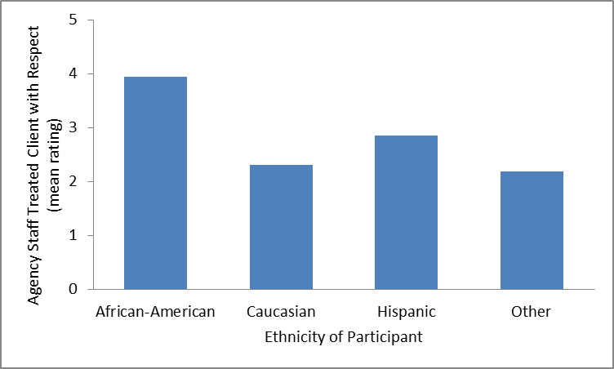

Figure 6: Respect Culture and Ethnicity
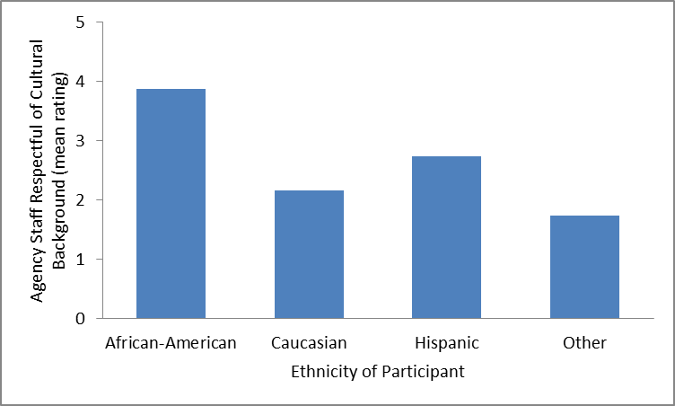

Figure 7: Friendliness and ethnicity
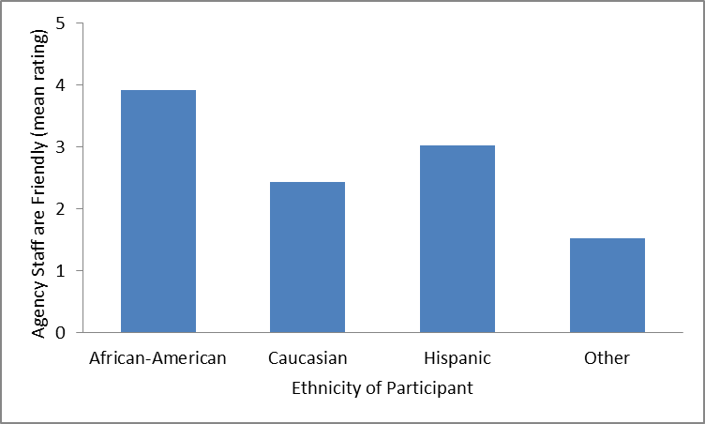

Figure 8: Worth helping and ethnicity
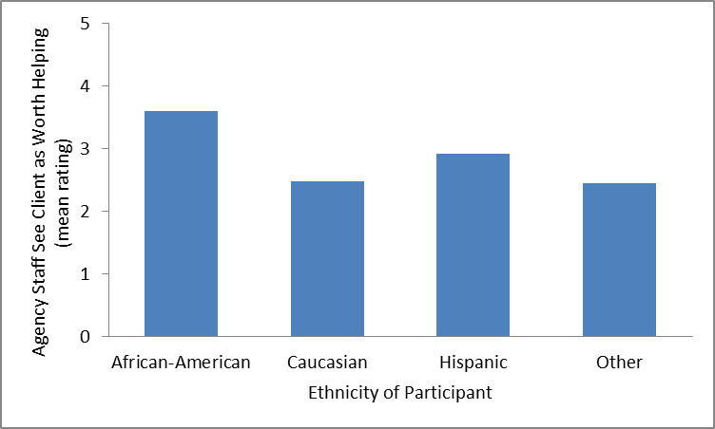

Finally, in order to determine if any significant differences existed in how males and females rated their satisfaction with agencies, independent samples T-tests were conducted on all satisfaction questions. Significant differences were found on ten satisfaction questions; on these ten items males were less likely to agree that agencies were helpful in areas related to dissemination of information (e.g., staff gave me information about my rights), recommending agencies for future use or to friends, and being treated with respect.
Summary and Implications of Findings
Overall, the majority of respondents expressed satisfaction with various aspects of agency service access and delivery. In general, people knew where to access the majority of services. However, findings indicate that certain subsets of respondents were not cognizant of where to receive some services and have not been satisfied with the services they have utilized. Specifically, males and African American respondents reported significantly less satisfaction in almost all service utilization areas, as did Hispanic respondents to a lesser extent. Furthermore, African American and male respondents were significantly less likely to know where to obtain services.
This study cannot determine why these differences exist; more in-depth research would be needed to do so. With that caveat in mind, we offer the following suggestions:
- More targeted outreach and/or education may be needed to ensure that males and African-American social service consumers are aware of the opportunities in the Siouxland region. From a practical standpoint, this type of targeted approach has the potential to help agencies ensure that they are providing outreach resources to those who truly need it. This allows the greatest benefits relative to costs invested.
- There is a perception amongst the majority of African American respondents and some Hispanic respondents that they are not being respected or treated in a friendly manner. They also generally reported less satisfaction with having agency rules and guidelines fully explained. The perception does appear to matter, as noted by the fact that African American and Hispanic respondents were less likely to recommend services to others and would be less likely to use agencies in the future. Therefore, some agency staff may benefit from additional training and/or education in cultural or gender sensitivity.
Individual agency directors are more than welcome to contact Dr. Regan Murray at the SRC if they would like feedback specific to their agency. You may reach her at regan.murray@briarcliff.edu; 712-279-1619.

Appendix 1:
Knowledge and Gender
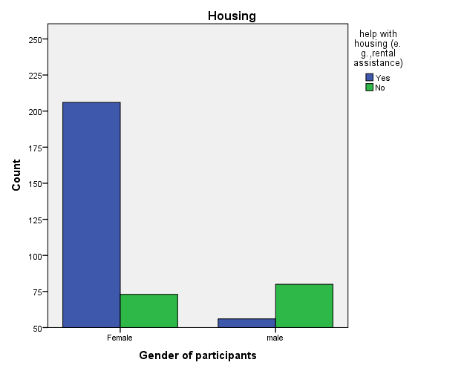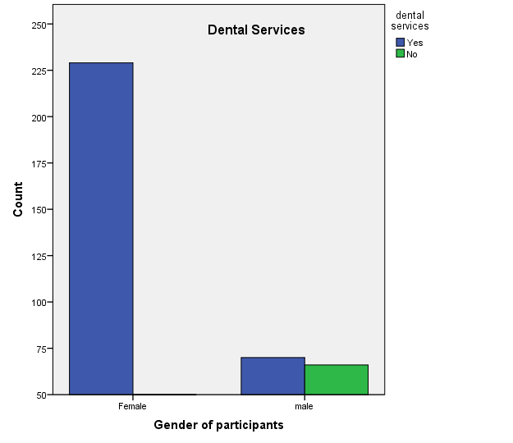
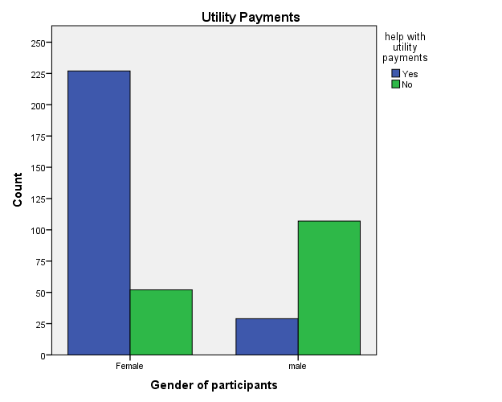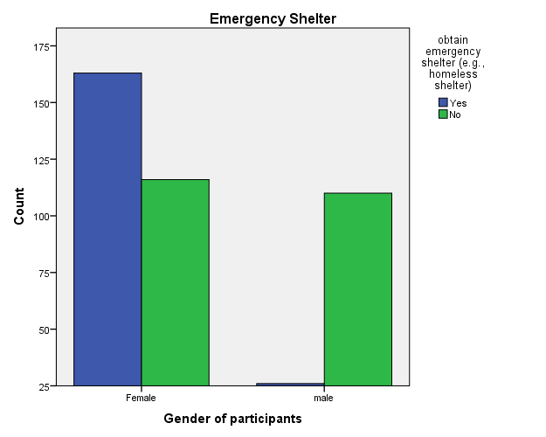

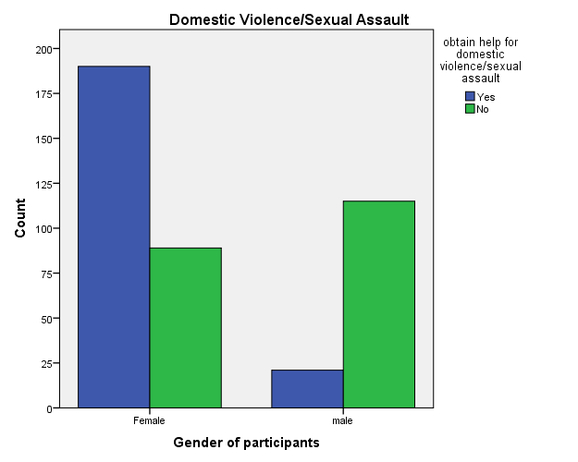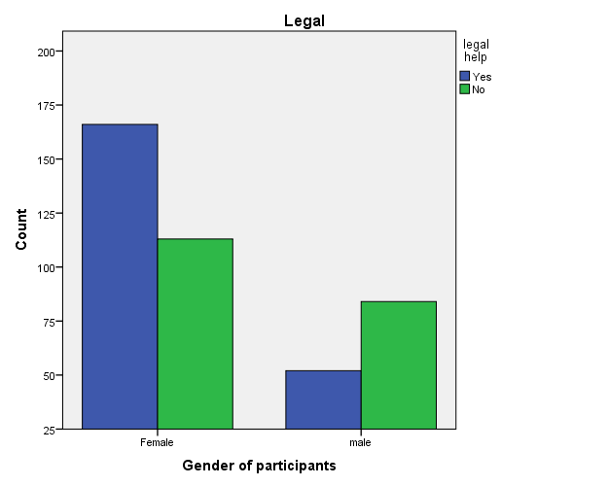
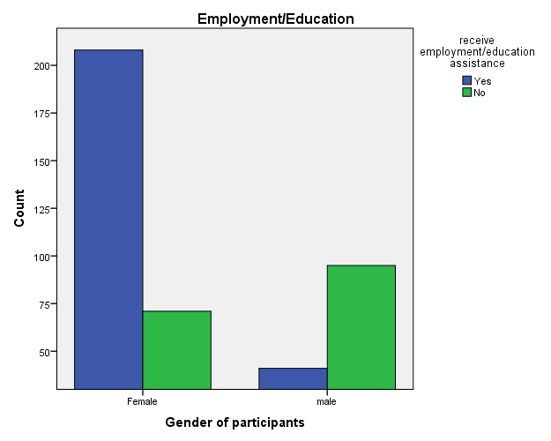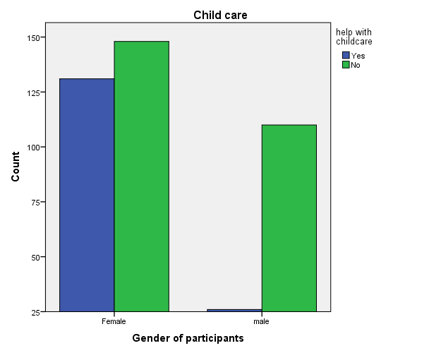

Knowledge and Ethnicity
